FOOD/INSECT EMERGENCY ANAPHYLAXIS CARE PLAN and MEDICATION AUTHORIZATION
Connecticut State Law and Regulations 10-212(a) require a written medication order of an authorized prescriber, (physician, dentist, optometrist, advanced practice registered nurse or physician's assistant, and for interscholastic and intramural sports only, a podiatrist) and parent/guardian written authorization, for the nurse, or in the absence of the nurse, a qualified school personnel to administer medication.
School:
STUDENT INFORMATION | ^{Student Name} | ^{DOB:}
 | ^{Home/Cell Phone} | ^{Grade}
 | KNOWN LIFE-THREATENING ALLERGIES: PEANUTS TREE NUTS  MILK SOY WHEAT SHELLFISH FISH (OTHER)  BEE STINGS LATEX EGGS:_________________ OTHER:  Confirmed with allergy testing yes no | ^{History of Asthma? No Yes}  (Increases risk of severe reaction)  Severe Anaphylactic Reaction? Yes,  This child has an extreme severe allergy. Give Epinephrine immediately if allergen was likely eaten, at onset of any symptoms and follow the protocol below.
 | ^{KNOWN ORAL ALLERGY SYNDROME:} No Yes (list):
 | - Provide separate medication authorization if treatment indicated

TREATMENT PLAN | AFTER EXPOSURE TO KNOWN OR SUSPECTED ALLERGY  & ANY OF THESE SYMPTOMS:  AIRWAY: Difficulty breathing, swallowing, chest tightness, wheeze  THROAT: Tight, hoarse, swollen tongue, difficulty swallowing/drooling  CARDIAC: Dizzy, faint, confused, pale or blue, hypotension, weak pulse  &/OR  ANY COMBINATION OF SYMPTOMS FROM DIFFERENT BODY AREAS:  - Swollen lips, repetitive cough, sneezing, profuse runny nose  - Hives, itching (anywhere), swelling (e.g., eyes)  - Nausea, Vomiting, diarrhea, crampy pain |  | follow this protocol:  1. INJECT EPINEPHRINE IMMEDIATELY!  2. Call 911  3. Lie down if able, avoid rapid upright positioning & continue monitoring  4. Give additional medications as ordered  - Antihistamine  - Bronchodilator/Albuterol if has asthma  5. Notify Parent/Guardian  6. Notify Prescribing Provider / PCP  7. When indicated, assist student to rise  very slowly.

EPINEPHRINE | Epinephrine Auto-injector, Jr (0.15mg) IM side of thigh Epinephrine Auto-injector (0.3mg) IM side of thigh  - A second dose of epinephrine can be given 5 minutes or more if symptoms persist or recur.  Relevant Side Effects Tachycardia Other: Medication Allergies NKDA Other:
 | Medication shall be administered during school year: | ^{2018 to 2019} | NOTE: if nurse is not available, the epinephrine auto  injector may be given by designated school personnel with  exposure or for any anaphylaxis symptoms

TO BE COMPLETED BY PARENT AND AUTHORIZED HEALTHCARE PROVIDER: REQUIRED
AUTHORIZATION | - Confirms student is capable of carrying medication Yes No  - Confirms student is capable to safely and properly administer medication Yes No  If a child refuses/is unable to self-treat, a trained personnel must be available and able to administer medication  Prescriber’s Signature: Date | Date:  Prescriber’s printed name or stamp
 | Parent: I hereby request that the above ordered medication be administered by school personnel and consent to communications between the school nurse and the prescriber that are necessary to ensure safe administration of this medication. This protocol will be in effect until the end of the current or extended school year. This medication will be destroyed if not picked up within one week following termination of the order or the end of the school year. Whichever comes first, unless the student will be attending an extended school year (ESY) program. A new protocol will be needed for the next school year. I have received, reviewed and understand the above information.
 | Parent’s Signature: Date

EMERGENCY CARE PLAN FOR STUDENT 2018-2019
NAME: SCHOOL/GRADE/TEACHER:
ALLERGY: DATE OF BIRTH:
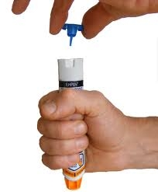
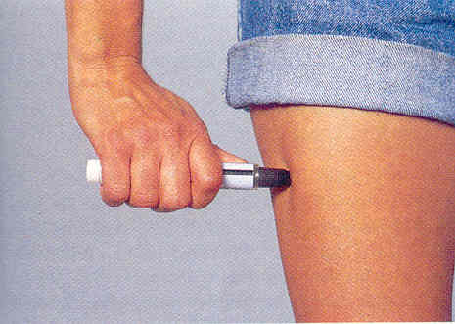
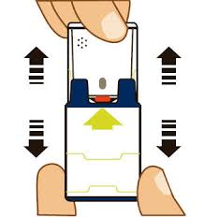
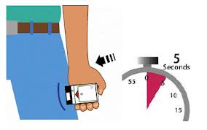

________________________________ ________________________________ ________________________________
Parent Student (if applicable) School Nurse
EMERGENCY CONTACTS EMERGENCY/PHYSICIAN CONTACTS
- Name & Relation: 1. Name & Relation:
Phone: Cell: Phone: Cell:

- Name & Relation: 2. Name & Relation:
Phone: Cell: Phone: Cell:
EPI AUTO-INJECTOR DIRECTIONS:
☐ For EPIPEN and EPIPEN JR.:
- Pull off blue activation cap.
- Hold orange tip near outer thigh (always apply to thigh).
Okay to inject through clothing.
- Swing and jab firmly into outer thigh until Auto-Injector mechanism functions. Hold in place and count to 10. Massage injection area for 10 seconds.
- Auto-Injector should then be removed and taken with you to Emergency Room.
☐ For Auvi-Q:
- Follow verbal instructions.
- Pull off red safety guard. Pull firmly to remove.
- Place black end against middle of outer thigh (through clothing if needed.) Then press firmly and hold in place for 5 seconds. Take the Auto Injector to the Emergency Room.
☐ For Generic Epinephrine Auto-Injector:
- TWIST and pull off outside container.
- Pull off BOTH end caps.
- Hold red tip against middle of outer thigh. OK to inject through clothing.
- Press down hard until needle enters the thigh. Hold in place for 10 seconds.
- Check red tip. If needle is exposed, medication has been received. If needle is not visible, repeat steps 3 and 4.
- CAREFULLY place injector back into outside container, needle tip first. Take the container to the Emergency Room.
IF ALLERGEN LIKELY EATEN (OR STUDENT STUNG), FOLLOW THIS EPINEPHRINE PROTOCOL AT THE ONSET OF ANY OF THE ABOVE SYMPTOMS:
1. Administer Epi Auto-Injector: _______0.15mg _______0.3mg.
2. Have someone call 911 for ambulance, don’t hang up, and stay with student.
- Administer Benadryl: _____ tablet(s), _______ tsp. liquid, ______No Benadryl ordered.
- Administer albuterol if authorized (has asthma).
- Have student lie down, if able, with feet above level of head until EMS arrives.
- Notify school and parent/guardian as soon as possible.
Insert picture here
SYMPTOMS OF ANAPHYLAXIS:
- Chest tightness, shortness of breath, cough, wheezing, profuse runny nose
- Dizzy, faint, pale, blue lips/skin, confused
- Tightness and/or itching in throat, difficulty swallowing, hoarseness, drooling
- Swelling of lips, tongue, throat, eyes, face, hands, feet
- Hives, itchy mouth, itchy skin, itching (anywhere)
- Nausea, vomiting, diarrhea, crampy pain

