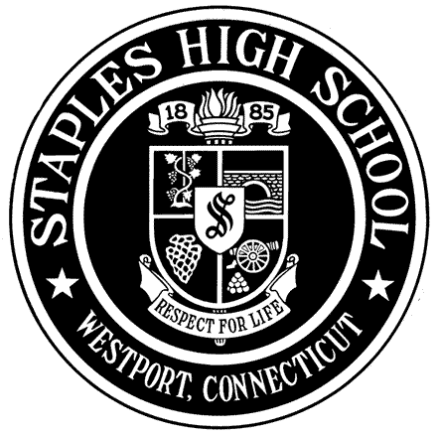
STAPLES HIGH SCHOOL
70 North Avenue, Westport, Connecticut 06880

Guidance Department Phone: (203) 341-1225 Fax: (203) 341-1235

Counselor Recommendation Questionnaire (Parent/Guardian)

The purpose of the Counselor Recommendation Questionnaire is to provide a description of your child that the school counselor can refer to when writing his/her college recommendation. Any specifics you can offer including examples and anecdotes are extremely useful. Please note that only your child’s school counselor will have access to this document.

Name of Student:

Name of Parent(s)/Guardian(s):

Phone: Email:
School Counselor:

Any information I provide may be used by my child’s counselor in his/her recommendation and may be subject to verification. I certify that all information provided in this document is my own work, factually true, and honestly presented.

Parent/Guardian Signature(s): Date:

Answer the following questions as completely as possible, typing your response below each question or attaching additional sheets. Share recent anecdotes and specific examples you think would be helpful.

- If you had to describe your child in three adjectives, what would they be?

Adjective | Example

- What has your child accomplished during the past three or four years that is most meaningful? Please do not recount your child’s resume.

- Are there any unique personal or family circumstances that have affected your child?

- Relate a favorite recent story or anecdote that best describes your child.

- What do you view as your child’s strengths and challenges in or outside of school? Please explain.

- What do you enjoy doing with your child?

- If your child has an IEP, 504, or extenuating circumstances that have warranted special accommodations in high school, do I have your permission to discuss it in the counselor recommendation as a way of providing context for academic performance?

- Is there any additional information you would like your child’s school counselor to know?

