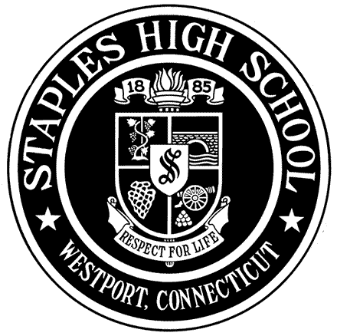
STAPLES HIGH SCHOOL
70 North Avenue, Westport, Connecticut 06880

Guidance Department Phone: (203) 341-1225 Fax: (203) 341-1235

Reference Form
For Counselor Recommendation

Students are encouraged to distribute the Reference Form to coaches, club advisors, supervisors of community service, employers, etc. This form can also be used for teachers other than those already writing a college recommendation letter. This form is not sent to colleges and is solely an aid for the school counselor. It is not a substitution for the teacher letters of recommendation.

Section I – (to be completed by student)

Student Name: Student’s School Counselor:

Reference Name:

Section II – (to be completed by reference)

Please complete the questions below describing your impressions of the student. This information is helpful to the school counselor for the student’s letter of recommendation, and we thank you for your time and feedback!

How long have you known this student and in what capacity?

What personal qualities, skills, or aspects of this student’s character stand out to you the most?

Share one or two examples or anecdotes that come to mind about this student from your experience with them.

Reference Signature: Date:

Reference Email Address:

Please email this form to: Susan Fugitt, SHS Guidance Department at sfugitt@westportps.org

