Daniel Westphal
Mr. Scrofani

Quantum Mechanics Independent Study Final Project:
Using Macroscopic Analogies to Understand the Quantum World

Introduction:
For my final project in my quantum mechanics independent study, I assembled a simplified quantum mechanics guide. When I began my independent study, my mentor and I looked through several different textbooks. Most started off with complex concepts involving high level mathematics (like linear algebra) despite having the word “intro” in their title. It was difficult to find a true introductory textbook. Even the textbook I ultimately worked with often assumed that the reader had prior knowledge in quantum mechanics. This paper aims to explain quantum mechanical concepts in more “real world” terms by analogizing the concepts to macroscopic events that people are familiar with. It will also explain the concepts in terms of what they actually are in quantum mechanics.
In order to determine which concepts would be explained, my mentor and I reviewed the main concepts covered in the textbook. It was concluded that the paper would contain concepts including the Schrodinger Equation, the Uncertainty Principle, Quantum Tunneling, Intrinsic Angular Momentum & the Stern-Gerlach Experiments, and the Einstein–Podolsky–Rosen (EPR) Paradox.

The Schrodinger Equation:
Quantum Mechanics Explanation:
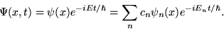
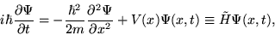
The Schrodinger Equation is a quantum mechanical function that describes the evolution of the wavefunction over time. The equation involves the time-dependent wave function (ψ), the potential (V(x)), and the hamiltonian (H). A central point in quantum mechanics is solving the Schrodinger Equation for the wave function. The wave function gives us the state of a quantum mechanical particle. One way of solving the Schrodinger Equation is by assuming it is a separable function of time and position. This means that the wave function equals some function of time multiplied by some function of position. Solving the Schrodinger Equation under this assumption gives the equation on the right. This equation can actually be expanded into a sine/cosine function with an imaginary component using a mathematical formula called Euler’s Formula.
The wave function in and of itself is not often explicitly examined in quantum mechanics since it, in that form, does not tell us much about the particle’s qualities. However, the square of the wave function can be used as a way of finding the probability of the particle the wave function describes being within a certain region. Taking the integral of the square of the wave function from a to b gives the probability of the particle being between a and b. We also know that taking the integral from negative infinity to positive infinity gives us 1, since the particle is definitely somewhere.

Analogy:
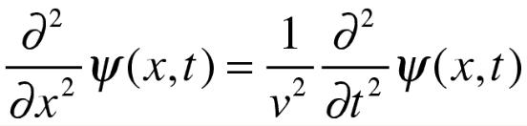
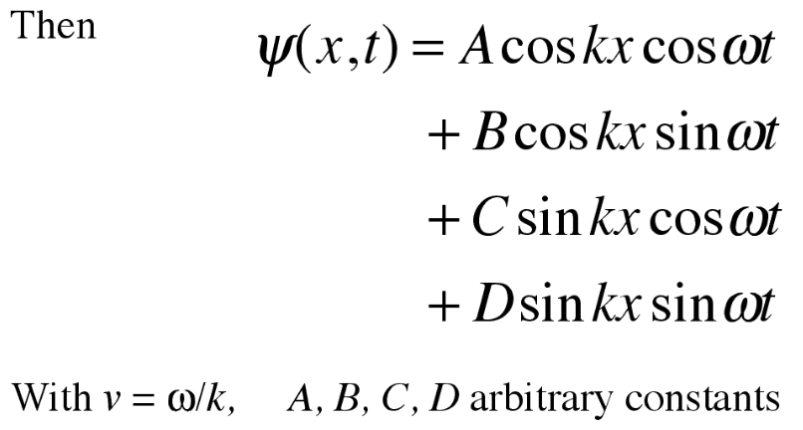
The Schrodinger Equation is similar to the wave equation in classical mechanics. The classical wave equation (as seen on the right) is similar looking to the Schrodinger Equation seen above. Solving the classical wave equation in the same way we solve the Schrodinger equation gives us the solutions seen on the right. The del symbols represent calculating the rate of change (since there is a 2, the operation represents finding the rate of rate of change of the wave function with respect to whatever variable is underneath it). The solutions we get to the classical wave equation fit with how we think about classical waves. Sound and light, for example, travel sinusoidally as seen on the right.
The waves given by the classical wave equation are very different than the waves from the Schrodinger Equation, despite their graphical representation seeming somewhat similar. The Schrodinger Equation says that extremely small particles have a wave-like probability distribution regarding their position, but it does not say that extremely small particles are waves (this is a very large misconception). The way the Schrodinger Equation is structured ensures that particles can’t just have a made up probability distribution for its position like ψ = A(x^2+3t), but instead must have one that fits the equation. The classical wave equation, on the other hand, refers to actual waves.
The Uncertainty Principle:
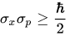
Quantum Mechanics Explanation:
Heisenberg’s uncertainty principle (as seen on the right) is a mathematical inequality that relates the precision with which one can measure a particle’s momentum and position. The inequality states that the standard deviation of position (x) times the standard deviation of the momentum (p) must be greater than the reduced planck constant divided by two. This equation essentially states that if one wants to measure either position or momentum with more precision, they must sacrifice some precision of the other measurement. The uncertainty principle exists regardless of the precision of instruments used to actually measure the qualities of the particle. Instead, the uncertainty principle arises from inherent parts of the particle’s wave function properties. The uncertainty principle comes from the concept that we can no longer think of quantum particles as particles, but instead as waves (even though they are not actually waves).
We can see the uncertainty principle when looking at functions to represent a particle. On the right is a sine wave that represents knowing the momentum of a particle (since there is a very clear wavelength), but since the distribution of the function spans essentially forever, the position is unknown. However, as the wave function becomes more localized we can more clearly determine position and not determine the momentum as much (since it’s more difficult to figure out the wavelength). This is shown on the right.

Analogy:
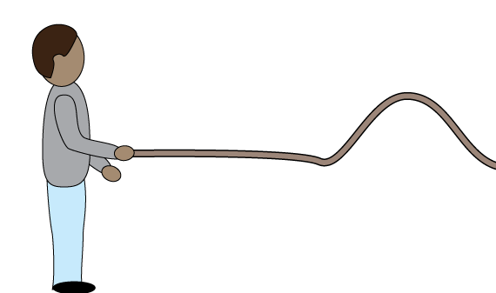
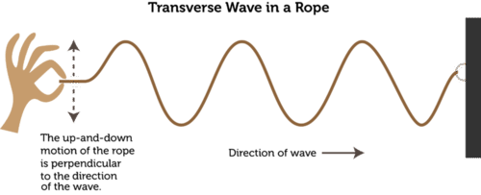
The uncertainty principle can be analogized to a rope with one end mounted to a wall and the other end in your hand. When you raise the rope and bring it down quickly it creates a moving peak on the rope (as seen on the right). It is extremely easy to tell where the peak (or the particle) is. It is, however, difficult to figure out how fast the peak is traveling. This is because the speed of the peak depends on the width of the peak and the frequency with which it occurs, both of which are hard to measure with one singular peak. It’s not just that the frequency is hard to measure, but instead it isn’t really definable for one peak. It’s as if the frequency emerges as more pulses emerge. Yes, we can try to calculate the frequency of a single pulse, but we can also calculate the wavelength of a chair. Just because we can calculate it doesn’t mean that it really is a definable or relevant property.
However, if one were to continuously create peaks (as shown in the second diagram on the right) it becomes increasingly difficult to determine where exactly the peak you just made is, since there are so many different peaks on the rope now. Likewise to what was said at the end of the above paragraph, it’s as if the position of the peak no longer really exists. We can calculate the position of the peak (it’s everywhere), but that has no actual meaning which negates the whole point of calculating position. However, it is easier to tell the width of the peak (wave) and the frequency of the peak because there are more peaks.

Quantum Tunneling:
Quantum Mechanics Explanation:
Quantum tunneling is a quantum phenomena in which a subatomic particle is able to pass through a classically forbidden zone. A classically forbidden zone is a zone in which there is a greater potential energy than the energy a subatomic particle has. Classically speaking, the particle cannot enter or pass through this zone since it does not have enough energy to do so. However, something different happens within the quantum world. There is a chance that the particle is able to pass through the classically forbidden zone into another zone that it has enough energy to be in.
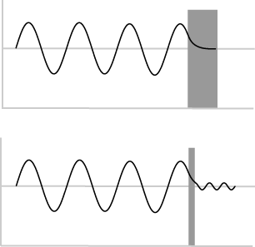
A diagram of this system can be seen on the right. The two different diagrams show what happens with quantum tunneling with different potential barrier widths. Quantum tunneling typically occurs with barriers that are 1-3 nanometers thick. It makes sense that it is more difficult for a particle to tunnel through a very large barrier. In the lower diagram on the right, the amplitude of the wave function decreases as it passes through the barrier and after it passes through the barrier. This is because the probability of the particle tunneling through the barrier is less than the probability that it has rebounded. Essentially, it is more likely for the particle to not pass through the barrier than it is for it to pass through it. One important thing to note is that the particle’s energy remains the same before and after tunneling.

Analogy:
Imagine that you’re throwing a baseball at a glass window. The baseball is representative of a subatomic particle and the window is representative of the classically forbidden zone. When the ball is thrown at the window at a very low speed (or low energy), we expect the ball to rebound from the window. However, in the quantum world there is a chance that the baseball simply passes through the window without breaking it. When the baseball is on the other side of the window it will still have the same speed (or energy) that it had immediately before going through the window. It’s also reasonable to say that the thicker the window is the more difficult it will be for the baseball to pass through it. This passing through the window is quantum tunneling.
Consider another situation in which the baseball is thrown with a greater speed at the same window. This time the ball has enough energy to pass through the formerly classically forbidden zone without tunneling. When the ball is thrown at the window the window shatters, representing how the ball has enough energy to overcome the barrier and that the ball can always enter through the zone where the window was with that speed.

Intrinsic Angular Momentum & The Stern-Gerlach Experiment:
Quantum Mechanics Explanation:
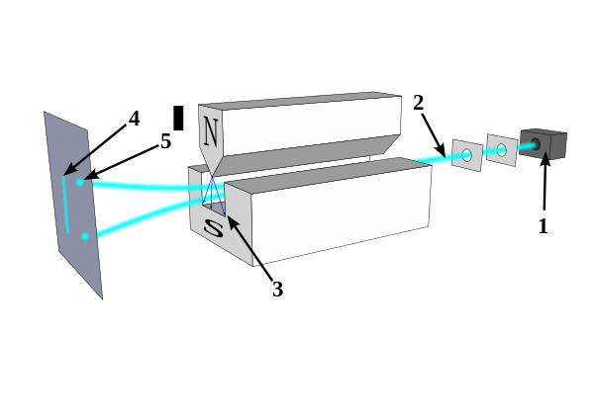
The Stern-Gerlach Experiment is the basis of particles having intrinsic angular momentum or “spin.” The experimenters fired a beam of silver atoms through a nonuniform magnetic field (a magnetic field that is stronger in certain regions than others). Silver atoms were chosen because they have a single outer electron and are, overall, electrically neutral. Since the magnetic field only exerts a force on moving charges, it is important that the atoms are neutral so that the charge of the atom does not impact the atoms displacement. The movement of the outer electron creates a magnetic field similar to that of a bar magnet. When the atoms were fired through the magnetic field, the experimenters thought the atoms would be like normal magnets with random orientations. Thus, they expected the atoms to create a continuous distribution on the plate it hits. However, this did not happen. Instead, the atoms were deflected up or down by a constant amount, with about half the atoms going up and the other half going down. This means that there are only two possible orientations of the dipole moment (or the magnet), up and down. The explanation posed for this was that electrons have an intrinsic angular momentum or spin that impacted the displacement of the atom more than the electron moving around the nucleus impacts the displacement. The electron spinning on its axis would generate a magnetic field since the charge on the electron is moving in a loop. The only issue is that the amount of intrinsic angular momentum an electron has is ħ/2, which would mean that a point on the outside of an electron would be moving magnitudes faster than the speed of light. Also, due to the small size and mass of an electron, it is debatable whether or not it can actually spin. So, despite electrons mathematically having spin, physically they don’t.
The Stern-Gerlach experiments also showed that you can only measure the spin of the electron around one axis with absolute certainty. For example, the original experiment discussed above measured spin in the Z direction. If you took the atoms that had a spin up in the Z direction and then measured them in the X direction you’d find that half of them have a spin up in the X direction and half have a spin down. However, when the spin in the X direction was measured, the previous measurement in the Z direction is no longer accurate. If you take the particles that just had their X direction spin measured and measured their spin in the Z direction about half would have a spin up and about half would have a spin down. This doesn’t seem possible since only particles that had a spin up in the Z direction were put into the X direction measurement mechanism. However, when the X direction spin was measured, it made it so that the initial Z direction spin measured was not accurate.

Analogy:
The concept of spin is similar to the idea of imaginary numbers. Mathematically, imaginary numbers manifest themselves just like any real number does, they can be added, subtracted, divided, and multiplied. In all ways they act like real numbers. The main difference is that imaginary numbers don’t have a “physical manifestation.” People can’t have an imaginary number of apples. So, in all ways they act like real numbers but are not actually real numbers. Similarly, spin has a mathematical manifestation, but not a physical manifestation. “Spin” in all ways acts like the spin we think of in real life, but does not actually occur or manifest in that way.
In order to understand the Stern-Gerlach Experiment and its implications think about a bag of half blue balls and half red balls, half of which are large and half of which are small. When one particle is observed, the observer can choose to know either the color or the size, but cannot know both simultaneously. All the balls are put into a machine that seperates them by color. Then, all the red balls are put into a machine that seperates them by size and we remove only the large balls. Lastly, all the large balls are put back into the machine that seperates them by color. One would think that all the balls that come out would have to be red since those are the color balls we put into the size measuring machine. But, similarly to what happened with the particles separated based off spin, they are not all red. This is because when the size machine separated the particles we knew what size the particles were, but we could not know what color they were and each particle therefore has a 50/50 chance of being blue or red. Although this is contrary to what one would normally expect, in the quantum world the accuracy with which one knows one variable impacts how well one can know another. Similarly, in this situation if one knows the size of the particle then the ball no longer actually has a color that we know.

The Einstein–Podolsky–Rosen paradox (EPR paradox)
Quantum Mechanics Explanation:
The EPR Paradox deals with quantum entanglement. Quantum entanglement is when groups of particles interact and share spatial proximity such that certain quantum qualities of each particle depend on one another. For example, say a neutral pi meson decays into a positron and an electron (in other words, one particle decays into two component particles). Since the meson had an overall spin of 0, we know that the positron and electron must have opposite spin (one will have a spin of +1/2 and the other -1/2). This is the only way for the meson to have had a spin of 0. While quantum mechanics does not allow us to determine the spin of each particle without observation, it does tell us that if you measure one particle to have a spin of +1/2 then the other must have a spin of -1/2.
The EPR Paradox is essentially an argument for the realist view of this situation rather than the orthodox one. The realist view simply states that the particles always had those spins since they were seperated from one another. The orthodox view, however, says that neither of those particles had a prescribed spin before we measured the spin of one of them. By measuring the spin of one particle, an opposite spin in the other particle is induced. There are several other theories, such as the many worlds theory, that exist, but do not have significant merit to them.
The EPR paradox poses a question regarding what happens when two previously entangled particles are separated by many light years. When you observe one particle and find it has a positive spin that means the other particle light years away must have a negative spin when we measure it. So what if we measure both particles one immediately after the other. If we follow the orthodox view, that means that one particle was able to influence the other (by “inducing” an opposite spin) from light years away within the time it took to measure the other particle. However, since no influence or force can travel faster than the speed of light then the particle must not have been able to influence the other one in time for the measurement. Those involved in formulating the EPR paradox used this as a justification that the particles actually did have these spins and that no spin is induced by the other. Others say that there are “hidden variables” that we cannot detect or measure that would allow us to figure out the spins of different particles without observation. The hidden variables theory essentially states that quantum mechanics is ultimately incomplete.

Analogy:
Say there are two sheets of paper. Upon observation, one will be blue and the other will be red. You take one sheet of paper and give the other to a friend. You look at your paper and find that it’s blue and your friend then looks at his and finds that it’s red. A realist would say that the papers were always blue and red and thus looking at the papers was simply just seeing what was already there.
The orthodox view, however, says that neither paper had a color until observed. It also says that the act of observing one paper and finding it’s blue makes the other paper red, most likely through some interaction of the two.
The hidden variable theory says that the pieces of paper have some sort of property that is undetectable to us. The theory does not say that the act of observing your paper has an effect on the other paper.

